Practicum No.5 Date:……….

Evaluate the Performance of Non-Pipelined and Pipelined Execution for the Given Instructions

- Practical Significance

Instruction pipelining is a fundamental performance enhancement technique used in modern processors. It improves throughput by overlapping instruction execution stages.
In a non-pipelined processor, each instruction completes all stages before the next instruction begins.
In a pipelined processor, multiple instructions are executed simultaneously at different stages.
Understanding the performance difference helps students:
- Analyze CPU throughput
- Calculate speedup
- Understand hazards and stalls
- Optimize instruction scheduling
Modern processors such as Intel Core series and AMD Ryzen use deep pipelining for high performance.

- Competency and Industry-Specific Practical Skills

Use the principles of computer architecture to optimize system performance
- Select appropriate addressing mode for a specific memory operation (PDO)
- Translate an instruction into its effective address (CDO)
- Use MATLAB to validate address calculations systematically (PDO)

- Relevant CO(s) (As stated in the Course Structure)

- CO1. Use the relevant instruction cycle to efficiently manage the processor's functionality.

- Practical Outcome (PrO) (As stated in the Course Structure)
- Develop a MATLAB program to compare non-pipelined and pipelined execution for the given Instruction.
- Related ADO(s) (As stated in the Course Structure)

- Follow ethical practices in designing or evaluating the system design.
- Apply systematic design principles and debugging techniques.
- Function effectively as a team member.

- Minimum Underpinning Theory (Include relevant content & images for this practicum.)

Non-pipelined execution processes one instruction completely before starting the next instruction.
Pipelined execution divides instruction processing into stages and overlaps multiple instructions to improve throughput.
Execution time of a processor depends on the total number of clock cycles required and the clock cycle time. In non-pipelined execution, each instruction passes through all $k$stages sequentially, so total cycles are equal to the product of number of instructions and stages.
In the MATLAB program, the execution time for non-pipelined execution is calculated using:
$$T_{non}=(n×k)×T_{clk}$$
In pipelined execution, the first instruction takes $k$cycles to fill the pipeline, and each additional instruction completes in one cycle. Therefore, the MATLAB formula used to compute pipelined execution time is:
$$T_{pipe}=(k+(n-1))×T_{clk}$$

- Practicum Set-up/Circuit Diagram/Algorithm/Flowchart (Include probable photos of experimental set-up.)

Students must have:
- MATLAB installed
- Script file: exp5_pipelining.m
- Input dataset (base, index, displacement, PC, SP, scale)
- Example instruction formats
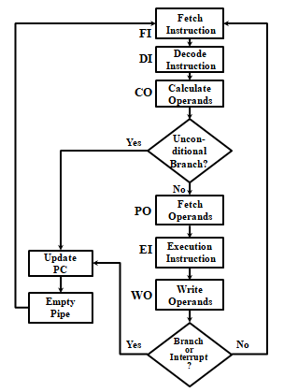

- Resources Required

S. No. | Resource | Suggested Broad Specification | Quantity
1 | MATLAB | (R2016b or newer) or GNU Octave (with mostly compatible syntax). | 1 No.
2 | PC | PC with MATLAB installed. | 1 No.
3 | Text editor / MATLAB Editor | - | 1 No.

- Safety Precautions

- Save work frequently.
- Comment code and include header describing author, date, input format and usage.
- For shared code, remove hard-coded absolute paths.
- Validate user inputs to avoid invalid logical values and runtime errors.

- Procedure (Self-Instructional)

a) Display the objective and available options to the user.
b) Accept the number of instructions and number of pipeline stages from the user.
c) Validate the entered numeric inputs.
d) Calculate cycles for Non-Pipelined execution:
Total Cycles = Instructions × Stages.
e) Calculate cycles for Pipelined execution:
Total Cycles = Instructions + (Stages − 1).
f) Measure execution time using tic and toc for relative comparison.
g) Compute speedup between pipelined and non-pipelined execution.
h) Display the number of cycles, execution time, and speedup in the MATLAB command window.
i) Repeat the process if the user wants to evaluate another case.
j) Exit the program when the user chooses to terminate.
Note: Instruction fetch is not considered while counting memory accesses; only operand access is considered. In indirect addressing, pointer dereferencing is assumed to focus on effective address computation.

Implementation of arithmetic addition using Non-Pipelined Method
Non-Pipelined – Initialization
clc; clear;
data = [10, 20, 30, 40, 50];
n = length(data);
result = 0;
Non-Pipelined – Execution
disp('Non-Pipelined Execution:');
tic;
for i = 1:n
fprintf('Adding %d to result...\n', data(i));
result = result + data(i);
end
elapsedTime = toc;
Non-Pipelined – Result
fprintf('Final Result (Non-Pipelined): %d\n', result);
fprintf('Execution Time (Non-Pipelined): %.6f seconds\n', elapsedTime);
Implementation of arithmetic addition using Pipelined Method
Pipelined – Initialization
clc; clear;
data = [10, 20, 30, 40, 50];
n = length(data);
pipelineStages = zeros(1, n);
Pipelined – Stage Processing
disp('Pipelined Execution:');
tic;
for i = 1:n
fprintf('Processing stage %d...\n', i);
pipelineStages(i) = data(i);
end
Pipelined – Result & Timing
result = sum(pipelineStages);
elapsedTime = toc;
fprintf('Final Result (Pipelined): %d\n', result);
fprintf('Execution Time (Pipelined): %.6f seconds\n', elapsedTime);

Non-Pipelined – Sample Output

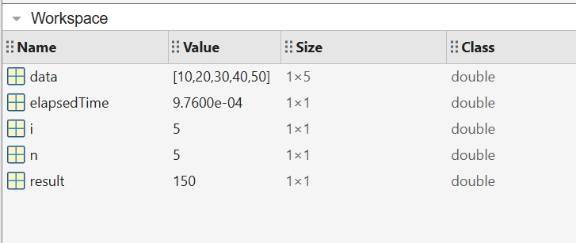

Non-Pipelined – Sample Output

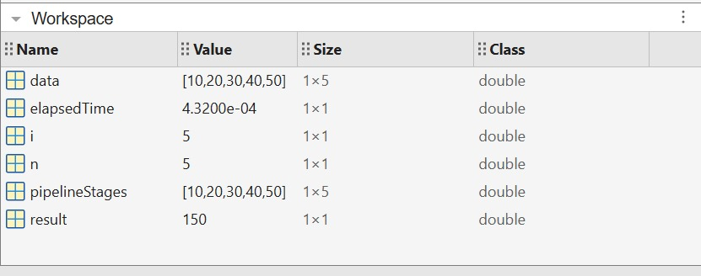

- Actual Resources Used (To be filled by the students)

S. No. | Name of Resource | Broad Specifications |  | Quantity | Remarks  (If any)
 |  | Make | Details
1 | Computer / Laptop | ASUS | Intel i5, 8GB RAM | 1 | Used for MATLAB execution
2 | MATLAB Software | MathWorks | MATLAB R2021a | 1 | Programming environment
3 | Operating System | Microsoft | Windows 11 | 1 | System platform

- Actual Procedure Followed

- The computer system was switched on and MATLAB software was opened.
- A new script file was created and the Non-Pipelined arithmetic addition program was written and executed.
- The output values such as result and execution time were observed in the Command Window and Workspace.
- Another script was created for the Pipelined arithmetic addition program.
- The program was executed and the execution time and result were recorded.
- The results of Non-Pipelined and Pipelined methods were compared.

- Additional Questions
- Execute the MATLAB program for non-pipelined and pipelined execution using the same number of instructions and clock cycle time. Compare the total clock cycles, execution time, and determine which method is more suitable for real-time systems.
CODE:
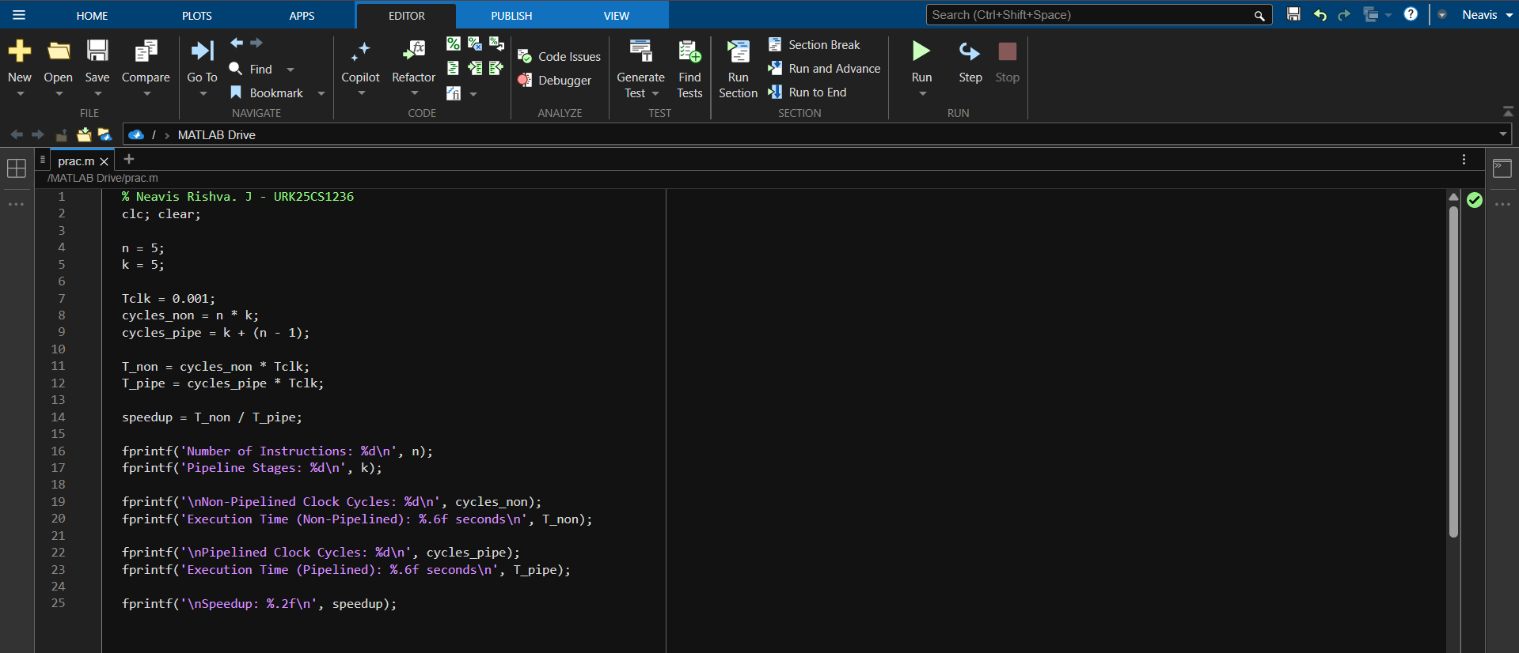
OUTPUT:
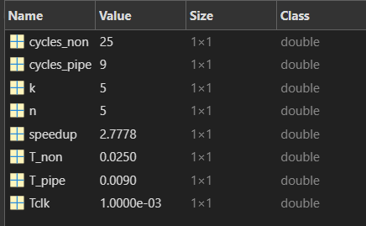
- Run the MATLAB program by increasing the number of instructions while keeping the number of pipeline stages constant. Analyze how execution time changes in both non-pipelined and pipelined modes and comment on the variation in speedup.
CODE:
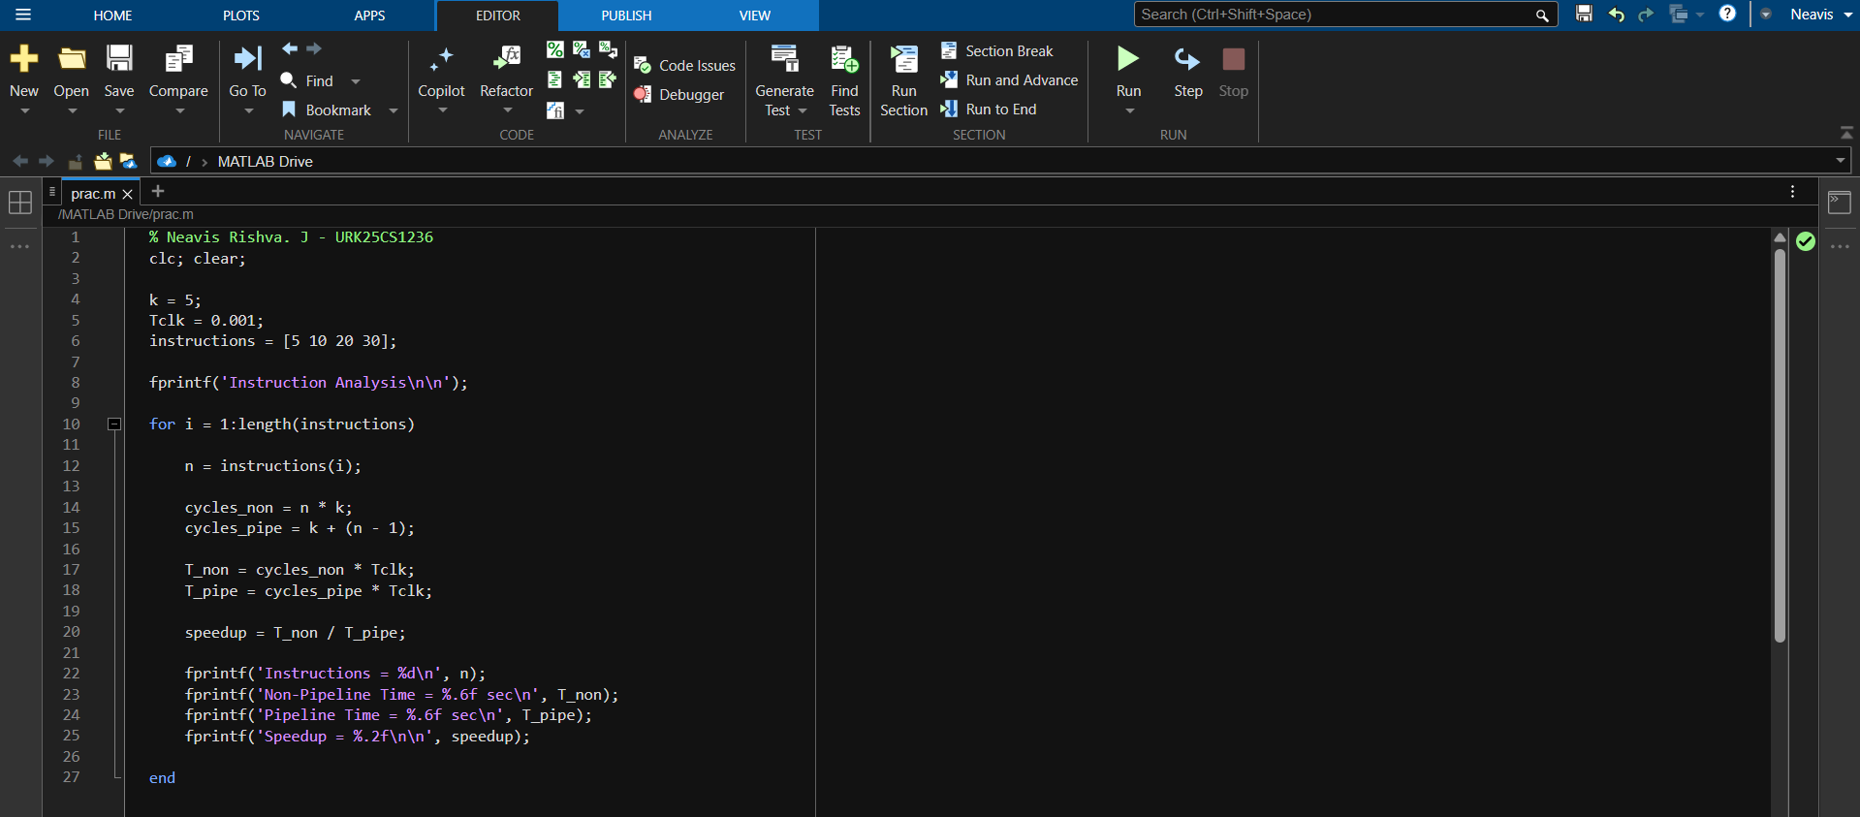
OUTPUT:
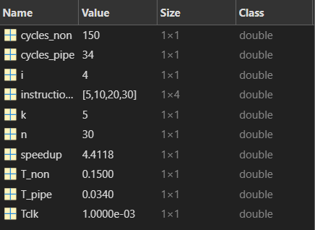
- Execute the program by increasing the number of pipeline stages while keeping the number of instructions constant. Analyze the effect of pipeline depth on execution time and overall performance.
CODE:
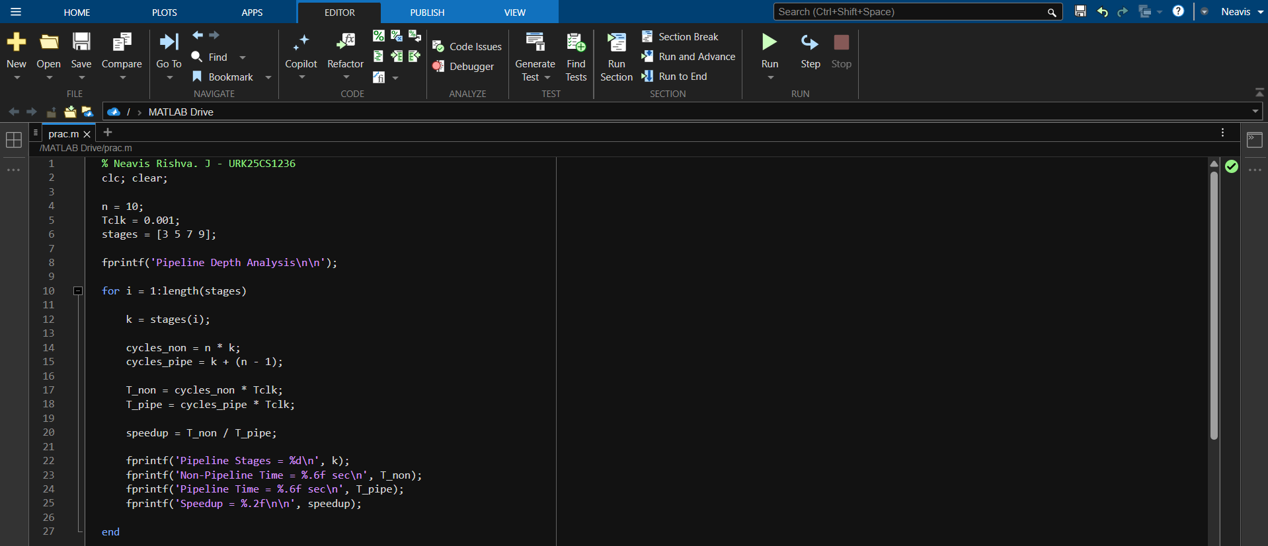
OUTPUT:
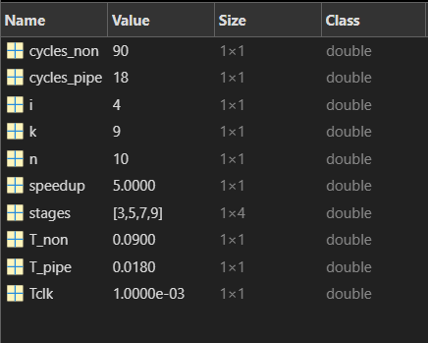
- Observations and Dimensional Measurement (To be filled by the students)

S. No. | Test Case ID | Instruction / Addressing Mode Selected | Input Values (Base / Index / Disp / PC / SP) | Effective Address (EA) | No. of Memory Accesses | Execution Time (tic/toc) | Execution Speed (Fast / Moderate / Slow) | Power Consumption (Less/More)
1 | TC-1 | Non-Pipelined Execution | n = 5, k = 5, Tclk = 0.001 | Not Applicable | 5 | 0.000976 s | Slow | More
2 | TC-2 | Pipelined Execution | n = 5, k = 5, Tclk = 0.001 | Not Applicable | 5 | 0.000432 s | Fast | Less
3 | TC-3 | Non-Pipelined Execution | n = 10, k = 5 | Not Applicable | 10 | Higher than TC-1 | Moderate | More
4 | TC-4 | Pipelined Execution | n = 10, k = 5 | Not Applicable | 10 | Lower than TC-3 | Fast | Less

Note: Instructions for Filling the Table:
- Test Case ID:
Assign a unique ID for each execution run (TC–1, TC–2, etc.).
- Execution Type Selected:
Mention whether the execution is Non-Pipelined or Pipelined.
- Input Values:
Enter the values provided in the MATLAB program such as:
Number of instructions (n),
Number of pipeline stages (k),
Clock cycle time (Tclk).
- Total Clock Cycles:
Record the total cycles calculated by the MATLAB program.
- For Non-Pipeline: $n×k$
- For Pipeline: $k+(n-1)$
- Execution Time:
Record the execution time computed in MATLAB using:
Execution Time = Total Cycles × Clock Cycle Time
- Speedup:
If calculated, record the speedup value obtained from:
Speedup = T_non / T_pipe
- Throughput:
Mention instructions completed per cycle (1/k for non-pipeline, ≈1 for pipeline after fill).
- Performance Classification:
Mark Lower Performance for Non-Pipelined execution and Higher Performance for Pipelined execution (based on execution time comparison).
- Remarks:
Comment whether pipelining improved performance and whether any stall cycles were considered.

- Results/Observation

- The Non-Pipelined execution performed arithmetic addition sequentially and required more execution time because each instruction was completed before starting the next one.
- The Pipelined execution processed instructions in overlapping stages, reducing total execution time and improving system performance

- Interpretation of Results

The results show that pipelining improves processor efficiency by allowing multiple instructions to be processed simultaneously in different stages.
This reduces total execution time compared to the non-pipelined method. As the number of instructions increases, the performance benefit of pipelining becomes more significant.

- Conclusions
The experiment demonstrated the difference between Non-Pipelined and Pipelined execution methods in processor architecture.
The pipelined method achieved faster execution due to parallel processing of instruction stages. Therefore, pipelining is widely used in modern processors to increase instruction throughput and improve overall system performance.

- Suggested Practicum Related Questions:

Note: Below are a few questions related to industry-specific higher-order thinking skills (HOT) that teachers must use to ensure students achieve the predetermined course outcomes.

- Justify how total clock cycles differ between non-pipelined and pipelined execution using MATLAB results, and explain the impact on execution time.
- Determine how increasing the number of instructions (n) affects execution time and speedup in both non-pipelined and pipelined architectures.
- Analyze how the number of pipeline stages (k) influences overall performance and theoretical speedup.
- Evaluate the effect of introducing stall cycles (hazards) on pipelined execution time compared to ideal pipelining.
- Generate a comparative analysis using MATLAB outputs to show how pipelining improves throughput but does not reduce individual instruction latency.
- Recommend whether pipelining is suitable for real-time systems based on execution time predictability and hazard behavior.
- References / Suggestions for further reading

- Computer Organization and Architecture – Instruction Set Architecture and Addressing Modes
- Processor Architecture Textbooks

- Suggested Assessment Scheme

The performance indicators given serve as a guideline for assessing the ‘process-related skills/LOs’ (marks to be awarded in real-time in the laboratory by the faculty member, as these cannot be measured after the practicum is over) and ‘product-related skills/LOs’

Note: The weightage for the process-related skills and product-related skills will change depending on the PrO, COs, and the competency related to the concerned course.

Performance Indicators |  | Maximum Marks | Marks Obtained
Process-related Skills: 18 Marks - 60%
1 | Correctly creating and running MATLAB scripts (coding hygiene, commenting, workspace handling). | 6
2 | Selecting appropriate arithmetic operations for the given data. | 5
3 | Following safety, coding ethics, and good laboratory practices (file management, backups). | 4
4 | Contribution as a team member (peer collaboration, sharing datasets, debugging). | 3
Product-related Skills: 12 Marks - 40%
1 | Producing accurate computation results and well-formatted MATLAB Table output. | 3
2 | Correct interpretation of logical comparisons. | 2
3 | Interpretation of results (clarity, mathematical validity). | 3
4 | Drawing meaningful conclusions using NEP-aligned verbs (justify, determine, generate). | 2
5 | Ability to answer practicum-related higher-order questions. | 1
6 | Submitting the report on time with screenshots and code | 1
Total |  | 30

To be filled by Student:

S.No. | Name of the Student | Register No.
1 | NEAVIS RISHVA. J | URK25CS1236

To be filled by the Faculty Member:
Marks Obtained |  |  | Name and Designation of the Faculty Member | Date of Evaluation
Process-Related Skills  (18) | Product-Related Skills (12) | Total  (30)

*******

